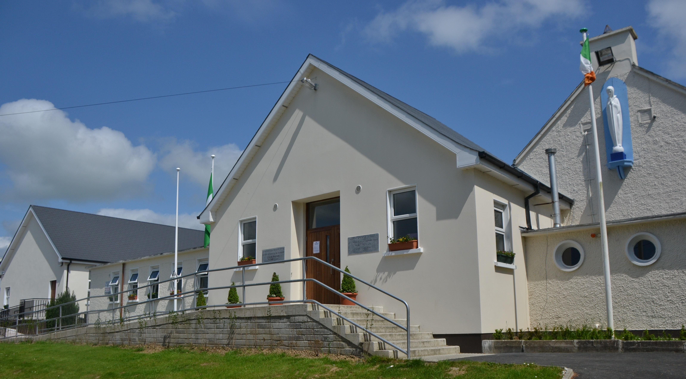

Christian Brothers Primary School,
BRIGOWN, MITCHELSTOWN, CO. CORK, P67 FY81.
Roll No: 17639W
TELEPHONE: (025) 24505
E-MAIL: office@cbspmitchelstown.com
WEBSITE: www.cbspmitchelstown.com

Our School Motto: Have Courage & Be Kind

Our Vision: That through positive learning experiences, each child will be stimulated to achieve his full potential, face life confidently and respectfully, mindful of his responsibility to the wider community.

APPLICATION FOR ENROLMENT
(Formulated in reference to our Data Protection Policy - G.D.P.R.)

All information you give on this form will be treated with the strictest confidence and only used for the benefit of your child.

PLEASE USE BLOCK CAPITALS TO COMPLETE THIS FORM

Child's First Name: _________________________________ Child's Surname: ____________________________________
Child's PPS Number: _______________________________ Country of Birth: ____________________________________
If other than Ireland please state, date of arrival in Ireland: ___________________________________________________
Child's Date of Birth: _________________________ (D.M.Y. format) PLEASE ATTACH ORIGINAL BIRTH CERTIFICATE /or Passport for identification purposes (will be returned) (Not applicable for children transferring from Bunscoil Na Toirbhirte)
Date of Intended Enrolment: _______________________ Class Child is entering: __________________________
Number of children in the family: ___________________ Placing of child in family (1st, 2nd etc.): ______________
Name and class of siblings already in the school: ________________________________________ ____________________
________________________________________ ____________________
Areas from Primary Online Database, which require your consent:
What is your Child’s Religion? _____________________ What is your Child's Nationality? ______________________
To which ethnic or cultural background group does your child belong? (please tick one)
White Irish Irish Traveller  Roma  Any other White Background 
Black or Black Irish - African Black or Black Irish - Any other Black Background 
Asian or Asian Irish - Chinese Asian or Asian Irish - Any other Asian background 
Other, including mixed race backgrounds 
N.B.: I/We consent □ or I/We do not consent □ (please tick as appropriate) for this information to be stored on the Primary Online Database (POD) and transferred to the Department of Education & Skills and to other primary schools my child may transfer to during the course of their time in primary school. I/We understand this will only be commenced if my child is accepted into the school. If you object to this information being sent to the Department, you must put this objection in a written letter and return to the school. If you want future information on this process, please visit the Department of Education's website - The Fair Processing Notice contains information on the purpose, legal basis for data collection and retention policy of the data.

Signed:___________________________________ Signed:___________________________________
Mother / Legal Guardian 1 Father / Legal Guardian 2
Date:______________ Date:______________

PARENT(s)/LEGAL GUARDIAN(s) Details: The following information is needed for registration purposes.
 | Mother / Legal Guardian 1: | Father/ Legal Guardian 2:
First Name:
Surname Name:
Address:

Eircode:
Mobile Number:
House Phone Number:
Work Phone Number: used only in emergency
E-mail address - Please print in BLOCK CAPTIALS
Occupation:
Nationality:
Level of English: (e.g. very little, some, fluent)
Language/s spoken at home:

With whom does the child normally reside: Name/s: ___________________________________________

Mobile Number for “text-a-parent”: _______________________________ (This is the only number school will contact re. closures, announcements etc. You must inform school if this number changes)
Alternative Emergency contact details, must be supplied in case of an emergency, if the parent(s)/legal guardian(s) cannot be contacted at the time.

Give names of 3 Contacts (other than parents/legal guardians) who will collect your child from school:
1st contact person if parent/legal guardian not available:
Name: _________________________Phone No. __________________________Relationship to your son: ______________
2nd contact person if parent/legal guardian not available:
Name: _________________________Phone No. __________________________Relationship to your son: ______________
3rd contact person if parent/legal guardian not available:
Name: _________________________Phone No. __________________________Relationship to your son: ______________
Please note, school can only release your child to those named.
You must inform school if somebody else will be collecting your child.
(N.B.: you will need to inform the school should address (es) / telephone number(s) change)

FOR SACRAMENTS:

Child's Religion: ________________________ Our school welcomes children who belong to other faiths/denominations. At time of enrolment, Parent(s)/Legal Guardian(s) are requested to liaise with Principal / Deputy Principal. Subsequently, Parent(s)/Legal Guardian(s) may meet with Class Teacher, about religious instruction.

Child's Mother's Maiden Name: (required for Sacraments)______________________________________
Yes
No
Has your child been Baptised:

Name & Address of Church of Baptism: ___________________________________________________________________
______________________________________________________________________________________________________PLEASE ATTACH COPY OF BAPTISIMAL CERTIFICATE. (will be returned) (Not applicable for children transferring from Bunscoil Na Toirbhirte)

PREVIOUS SCHOOL: (Please ensure to complete in full)

Name and address of previous school attended: _____________________________________________________________
______________________________________________________________________________________________________
Date your child last attended previous school: _____________________________________________________________ Class your son has been previously in: ____________________________________________
Name of Principal: ____________________________________________
Phone no. of previous school: ____________________________________________
Are there specific areas in which your child has displayed significant abilities / interest? ___________________________
______________________________________________________________________________________________________
Are there specific areas which your child finds difficult? ______________________________________________________

I / We give permission to the Principal / Deputy Principal, of C.B.S. Primary to discuss the needs of my / our son, with the Principal / Deputy Principal of the school listed above.
Yes
No

MEDICAL INFORMATION: (Separate Consent for Medical Attention Form attached)

Has your child ever been referred to a specialist / agency?
Yes
No

If yes, please give brief details for referral: _________________________________________________________________
____________________________________________________________________________________________________________________________________________________________________________________________________________
Yes
No
Has your child ever had any type of assessment?

If yes, please give details: ______________________________________________________________________________________________________
______________________________________________________________________________________________________

Please enclose copy of reports, assessments, e.g. Occupational Therapy, Speech & Language, Mental Health Services, other supports, professional reports etc.

Does your child appear to have any difficulties with the following?
Has your child any medical condition that the school should be aware of

Yes
Yes
Yes
Yes
Hearing: Speech: Vision: Co-ordination:
No
No
No
No

MEDICAL INFORMATION continued:
If you have answered yes to any/all of the previous questions, please give details here: ____________________________________________________________________________________________________________________________________________________________________________________________________________
______________________________________________________________________________________________________
____________________________________________________________________________________________________________________________________________________________________________________________________________
______________________________________________________________________________________________________

Please Tick Each Box As Applicable

- During your child’s time in C.B.S. Primary, he will undergo various Standardised / Diagnostic / Educational Tests.
Yes
No
I / We give permission for these tests to be carried out.

- Do you give permission for your child to go on school trips, under teacher supervision during the school day e.g. trips to the local town park, local historical buildings etc.
Yes
No

- Sometimes journalists visit our school to take pictures of the children e.g. awards/prizes, sporting events, first day at school etc. Do you give permission for your child to be photographed for school projects, local newspapers, and school related activities? (The Board of Management cannot be held responsible for pictures/video taken by parents at Sacraments, Celebrations, School Concert, Sports Days, etc.)
Yes
No

- Please visit our school website www.cbspmitchelstown.com Do you give permission for your child’s photo/work to be used on the school website/blog?
Yes
No

- Sometimes the school is requested to pass on names of children and their addresses to the Health Board for immunisation purposes / dental service, to secondary schools when children are transferring to second level, to sporting bodies when children are taking part in games outside the school. Do you allow the school to pass on this information to these three bodies?
Yes
No

- The school teaches Relationships and Sexuality Education (RSE). Full content of sensitive areas of programme included in Policy Booklet. Are you happy that your child participates in these classes?
Yes
No

No
Yes
- The information I / We have given in this form is accurate.

In signing this application form;
- I / We have read the Information Booklet and have read the following Policies on the school website - www.cbspmitchelstown.com; (under Policies Section - Policy Booklet) Anti-Bullying, Attendance, AUP, Child Safeguarding Statement, Code of Behaviour, Communication, Complaints Procedure, Data Protection, Enrolment, Mobile Phone, RSE.

- I am / We are aware that all school policies are available to view, by arrangement, at the school office.

- I am / We are agreeing to support the Board of Management and Staff in their implementation of school policies and to abide by same and to any agreed future amendments, going forward.

- I / We agree to support the staff in their efforts to provide a positive learning experience for all children in the school.

- I / We understand that it is a condition of enrolment that I / We abide by and accept all agreed school policies and procedures and any agreed amendments, going forward.

Parent(s) / Legal Guardian(s) signature(s):

_______________________ _______________________
Mother / Legal Guardian 1 Father/ Legal Guardian 2

Both Parent(s) / Legal Guardian(s) must sign this form, application will not be accepted without both signatures:

IF ANY OF THE DETAILS IN THIS FORM CHANGE - FOR EXAMPLE, IF YOU MOVE HOUSE, CHANGE YOUR PHONE NUMBER ETC. WOULD YOU PLEASE INFORM THE SCHOOL AT THE EARLIEST OPPORTUNITY.

Please ensure that you have included the following with your application:

1. Fully completed application form (please ensure All sections are completed in full, in BLOCK LETTERS) □Yes □No
2. Completed Consent for Medical Attention Form □Yes □No
3. Birth Certificate or Passport (if not transferring from Bunscoil na Toirbhirte) □Yes □No
4. Baptismal Certificate (if not transferring from Bunscoil na Toirbhirte) □Yes □No
5. Reports from previous school (where applicable, if not transferring from Bunscoil na Toirbhirte) □Yes □No
6. Both Parent(s) / Legal Guardian(s) have signed this form (where applicable) □Yes □No
7. Photocopying, Arts & Craft, Journal Money - €55 □Yes □No

Note: Photocopying, Art & Craft, Journal Money can be paid now, or, will be required on Day 1 of New School Year

Office Use Only
1. □Yes □No 2. □Yes □No 3. □Yes □No 4. □Yes □No 5. □Yes □No 6. □Yes □No 7. □Yes □No 8. □Yes □No 9. □Yes □No 10.□Yes □No

CONSENT FOR MEDICAL ATTENTION FORM

Child's Name: ___________________________________

Child's Address: ___________________________________
___________________________________
Parent/Legal Guardian 1 (Mother) Name: __________________________________Mobile No: ________________________
Parent/Legal Guardian 2 (Father) Name: __________________________________Mobile No: ________________________
In the event of ____________________________ (pupil’s name) requiring medical attention, for any reason, during school or during any activities under supervision of the school, I / We consent to his referral to such doctor or hospital authority, as the school authorities shall see fit.

I / We also consent to the Doctor or Hospital Authority concerned carrying out such treatment or operative measures, as may be considered necessary, including the administration of general or other anaesthetics.

I / We understand that the school authorities will make every effort to contact me / us first.

My child is allergic to: ____________________________________________________________________________________________________________________________________________________________________________________________________________

Medical History / Conditions, deemed necessary to inform doctors of in case of an emergency:
______________________________________________________________________________________________________
______________________________________________________________________________________________________

Yes
No
Are you a medical card holder:

Name & Address of Family Doctor: ___________________________________________________________________________________
___________________________________________________________________________________

Telephone No of Family Doctor: _____________________________________________

I give my consent:
Signed: __________________________________Parent/Legal Guardian 1 (Mother)

Date: __________________________________

I give my consent:
Signed: __________________________________Parent/Legal Guardian 2 (Father)

Date: __________________________________

Chairperson:  Principal:  Deputy Principal:  Assistant Principal: | Martin Kelly  Bernard O'Connell  Nigel Griffin  John Weir | C.B.S. Primary School, Brigown, Mitchelstown, Co. Cork  Telephone (025) 24505  E-mail cbsmitchprimoffice@gmail.com Website www.cbspmitchelstown.com

